Phantom Anthem of DTC (HARD)
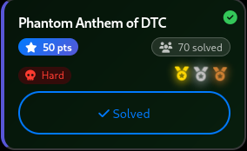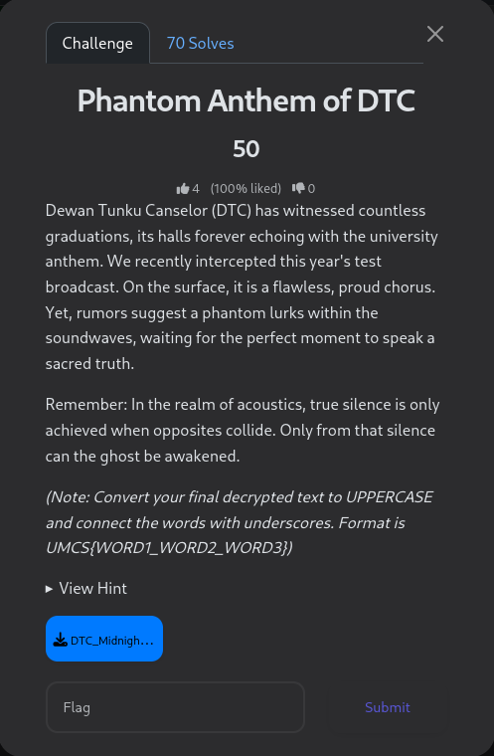
Hint:
Focus on the physical properties of stereo sound—what happens when two identical but opposing forces meet? As for the encrypted message you uncover, the father of our university holds the 'key', but you'll need to know exactly when he took his oath to find the right one.
The Anthem was opened with Audacity
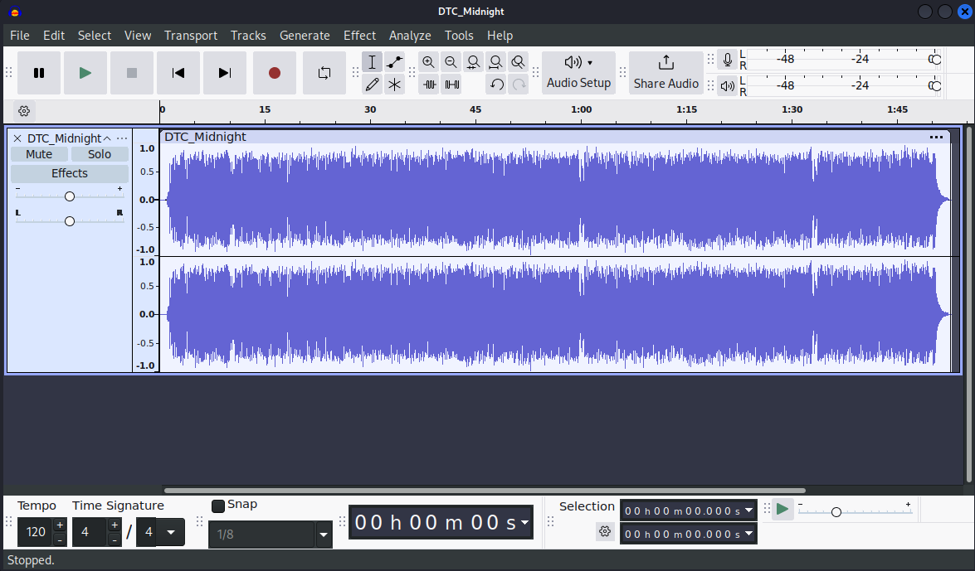
On audio played, the anthem regular.
Tried splitting the stereo to mono
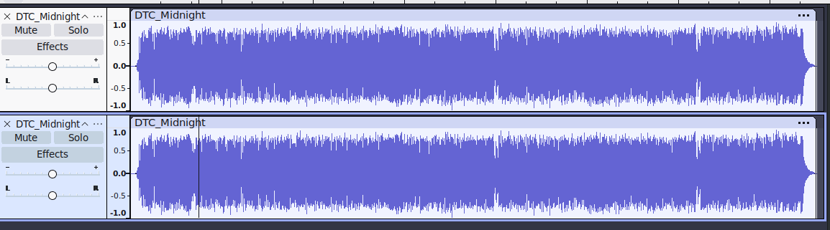
Then invert a track
On play, the audio of the 2 tracks are cancelled out. After listening in a while, patterns of sound can be heard in a morse code pattern in different timelines.
Writing down the morse code gives us:
.-.. ..- -.-- -.- -...
-... ..-. --.. . .--- -. .... .--. -.- . -..- --. -. - --- - ....
.. ..- -.-- -.-. ---
Translating the morse code gives us the output of:
LUYKB BFZEJNHPKEXGNTOTH IUYCO
We use Vigenene Decode with a key ‘TUNKU’ to decode the ciphertext:
SALAH ILMUPUNCAKEMAJUAN VKEJU
Sending over to the flag as:
UMCS{SALAH_ILMUPUNCAKEMAJUAN_VKEJU}
Does not give us the flag.
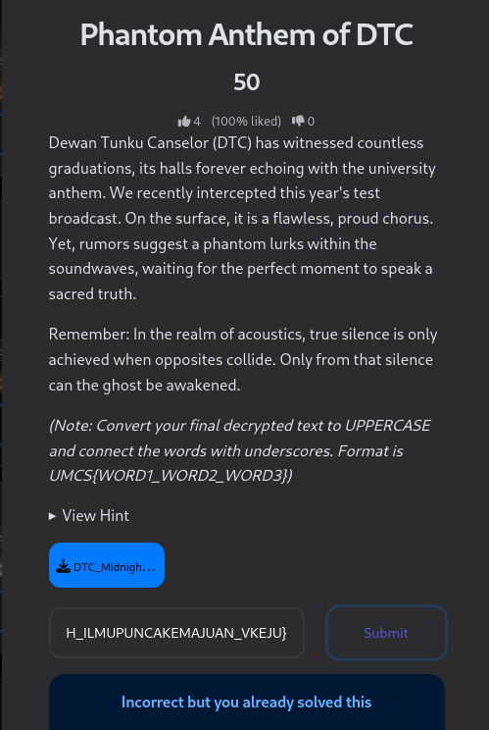
But Universiti Malaya has a motto:
"Ilmu Puncha Kemajuan"
With “Puncha” as in “PUNCA”, submit the flag as
UMCS{ILMU_PUNCA_KEMAJUAN}
